**PN Junction Theory**

A PN-junction is formed when an N-type material is fused together with a P-type material creating a semiconductor diode

N-type semiconductor material is made by doping a silicon atom with small amounts of Antimony and a P-type semiconductor material is made by doping another silicon atom with Boron.

these newly doped N-type and P-type semiconductor materials do very little on their own as they are electrically neutral. However, if we join (or fuse) these two semiconductor materials together they behave in a very different way merging together and producing what is generally known as a “**PN Junction**“.

When the N-type semiconductor and P-type semiconductor materials are first joined together a very large density gradient exists between both sides of the PN junction. The result is that some of the free electrons from the donor impurity atoms begin to migrate across this newly formed junction to fill up the holes in the P-type material producing negative ions.

However, because the electrons have moved across the PN junction from the N-type silicon to the P-type silicon, they leave behind positively charged donor ions ( ND ) on the negative side and now the holes from the acceptor impurity migrate across the junction in the opposite direction into the region where there are large numbers of free electrons.

As a result, the charge density of the P-type along the junction is filled with negatively charged acceptor ions ( NA ), and the charge density of the N-type along the junction becomes positive. This charge transfer of electrons and holes across the PN junction is known as **diffusion**. The width of these P and N layers depends on how heavily each side is doped with acceptor density NA, and donor density ND, respectively.

This process continues back and forth until the number of electrons which have crossed the junction have a large enough electrical charge to repel or prevent any more charge carriers from crossing over the junction. Eventually a state of equilibrium (electrically neutral situation) will occur producing a “potential barrier” zone around the area of the junction as the donor atoms repel the holes and the acceptor atoms repel the electrons.

Since no free charge carriers can rest in a position where there is a potential barrier, the regions on either sides of the junction now become completely depleted of any more free carriers in comparison to the N and P type materials further away from the junction. This area around the **PN Junction** is now called the **Depletion Layer**.

**The PN junction**

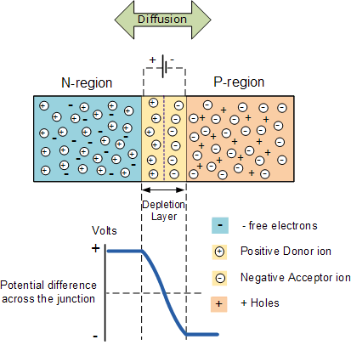

The total charge on each side of a *PN Junction* must be equal and opposite to maintain a neutral charge condition around the junction. If the depletion layer region has a distance D, it therefore must therefore penetrate into the silicon by a distance of Dp for the positive side, and a distance of Dn for the negative side giving a relationship between the two of:  Dp*NA = Dn*ND  in order to maintain charge neutrality also called equilibrium.

**PN Junction Distance**

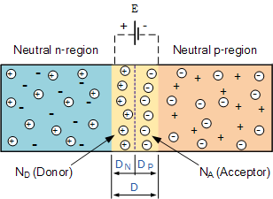

As the N-type material has lost electrons and the P-type has lost holes, the N-type material has become positive with respect to the P-type. Then the presence of impurity ions on both sides of the junction cause an electric field to be established across this region with the N-side at a positive voltage relative to the P-side. The problem now is that a free charge requires some extra energy to overcome the barrier that now exists for it to be able to cross the depletion region junction.

This electric field created by the diffusion process has created a “built-in potential difference” across the junction with an open-circuit (zero bias) potential of:

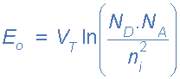

Where: Eo is the zero bias junction voltage, VT the thermal voltage of 26mV at room temperature, ND and NA are the impurity concentrations and ni is the intrinsic concentration.

A suitable positive voltage (forward bias) applied between the two ends of the PN junction can supply the free electrons and holes with the extra energy. The external voltage required to overcome this potential barrier that now exists is very much dependent upon the type of semiconductor material used and its actual temperature.

Typically at room temperature the voltage across the depletion layer for silicon is about 0.6 – 0.7 volts and for germanium is about 0.3 – 0.35 volts. This potential barrier will always exist even if the device is not connected to any external power source, as seen in diodes.

The significance of this built-in potential across the junction, is that it opposes both the flow of holes and electrons across the junction and is why it is called the potential barrier. In practice, a **PN junction** is formed within a single crystal of material rather than just simply joining or fusing together two separate pieces.

The result of this process is that the PN junction has rectifying current–voltage (IV or I–V) characteristics. Electrical contacts are fused onto either side of the semiconductor to enable an electrical connection to be made to an external circuit. The resulting electronic device that has been made is commonly called a PN junction Diode or simply Signal Diode.

Then we have seen here that a PN junction can be made by joining or diffusing together differently doped semiconductor materials to produce an electronic device called a diode which can be used as the basic semiconductor structure of rectifiers, all types of transistors, LED’s, solar cells, and many more such solid state devices.

**Biasing conditions for the p-n Junction Diode**

There are three biasing conditions for p-n junction diode and this is based on the voltage applied:

* Zero bias: There is no external voltage applied to the p-n junction diode.
* Forward bias: The positive terminal of the voltage potential is connected to the p-type while the negative terminal is connected to the n-type.
* Reverse bias: The negative terminal of the voltage potential is connected to the p-type and the positive is connected to the n-type.

**Forward Bias**

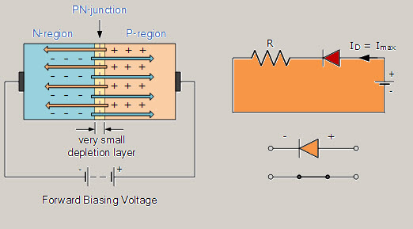Forward Bias Condition

When the p-type is connected to the positive terminal of the battery and the n-type to the negative terminal then the p-n junction is said to be forward-biased. When the p-n junction is forward biased, the built-in electric field at the p-n junction and the applied electric field are in opposite directions. When both the electric fields add up, the resultant electric field has a magnitude lesser than the built-in electric field. This results in a less resistive and thinner depletion region. The depletion region’s resistance becomes negligible when the applied voltage is large. In silicon, at the voltage of 0.6 V, the resistance of the depletion region becomes completely negligible and the current flows across it unimpeded.

**Reverse Bias**

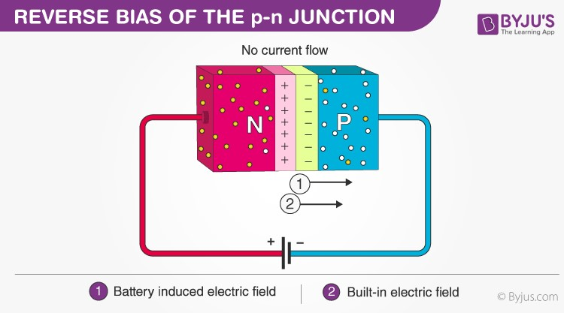

When the p-type is connected to the negative terminal of the battery and the n-type is connected to the positive side then the p-n junction is said to be reverse biased. In this case, the built-in electric field and the applied electric field are in the same direction. When the two fields are added, the resultant electric field is in the same direction as the built-in electric field creating a more resistive, thicker depletion region. The depletion region becomes more resistive and thicker if the applied voltage becomes larger.

**V-I Characteristics of PN Junction Diode**

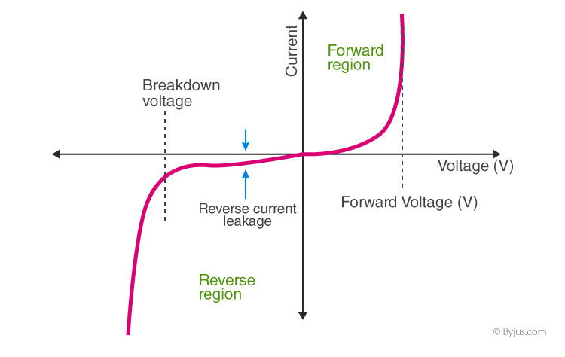

VI characteristics of PN junction diodes is a curve between the voltage and current through the circuit. Voltage is taken along the x-axis while the current is taken along the y-axis. The above graph is the VI characteristics curve of the PN junction diode. With the help of the curve we can understand that there are three regions in which the diode works, and they are:

* Zero bias
* Forward bias
* Reverse bias

When the PN junction diode is under zero bias condition, there is no external voltage applied and this means that the potential barrier at the junction does not allow the flow of current.

When the PN junction diode is under forward bias condition, the p-type is connected to the positive terminal while the n-type is connected to the negative terminal of the external voltage. When the diode is arranged in this manner, there is a reduction in the potential barrier. For silicone diodes, when the voltage is 0.7 V and for germanium diodes, when the voltage is 0.3 V, the potential barriers decrease and there is a flow of current.

When the diode is in forward bias, the current increases slowly and the curve obtained is non-linear as the voltage applied to the diode is overcoming the potential barrier. Once the potential barrier is overcome by the diode, the diode behaves normally and the curve rises sharply as the external voltage increases and the curve obtained is linear.

When the PN junction diode is under negative bias condition, the p-type is connected to the negative terminal while the n-type is connected to the positive terminal of the external voltage. This results in an increase in the potential barrier. Reverse saturation current flows in the beginning as minority carriers are present in the junction.

When the applied voltage is increased, the minority charges will have increased kinetic energy which affects the majority charges. This is the stage when the diode breaks down. This may also destroy the diode.

**Applications of PN Junction Diode**

* p-n junction diode can be used as a photodiode as the diode is sensitive to the light when the configuration of the diode is reverse-biased.
* It can be used as a solar cell.
* When the diode is forward-biased, it can be used in LED lighting applications.
* It is used as rectifiers in many electric circuits and as a voltage-controlled oscillator in varactors.